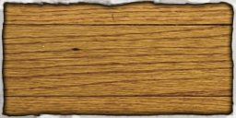
Table of Contents

Prologue(needs better name) ------------> Pg 2
The Cast ------------> Pg ?
Controls ------------> Pg ?
Getting Started ------------> Pg ?
Gameplay ------------> Pg ?
Happy Cabbage's Abilities ------------> Pg ?
Level Editor ------------> Pg ?

Prologue
Blah blah blah...

The Cast

A Button
Move Left
(Double-press
to dash)
R Button
Activate Leaf Shield
Controls
D Button
Move Right
(Double-press
to dash)

L Button
Charge/Fire Solar Beam
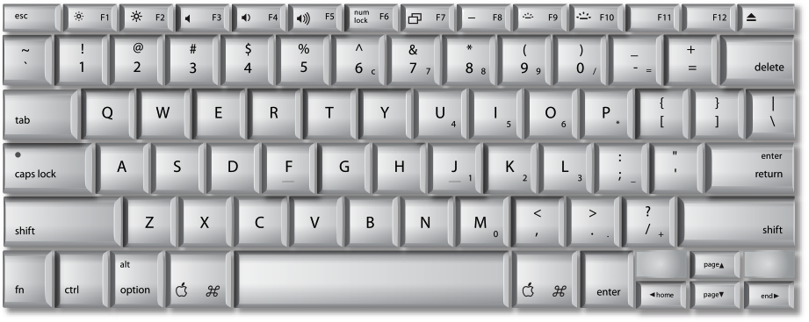
Spacebar
Jump
Select Stage
Left Arrow
See A Button
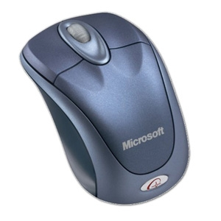
Left Mouse Button
Select (Main Menu)
Right Arrow
See D Button

Double click the Happy Cabbage Adventure.exe
Getting Started
file from your directory.

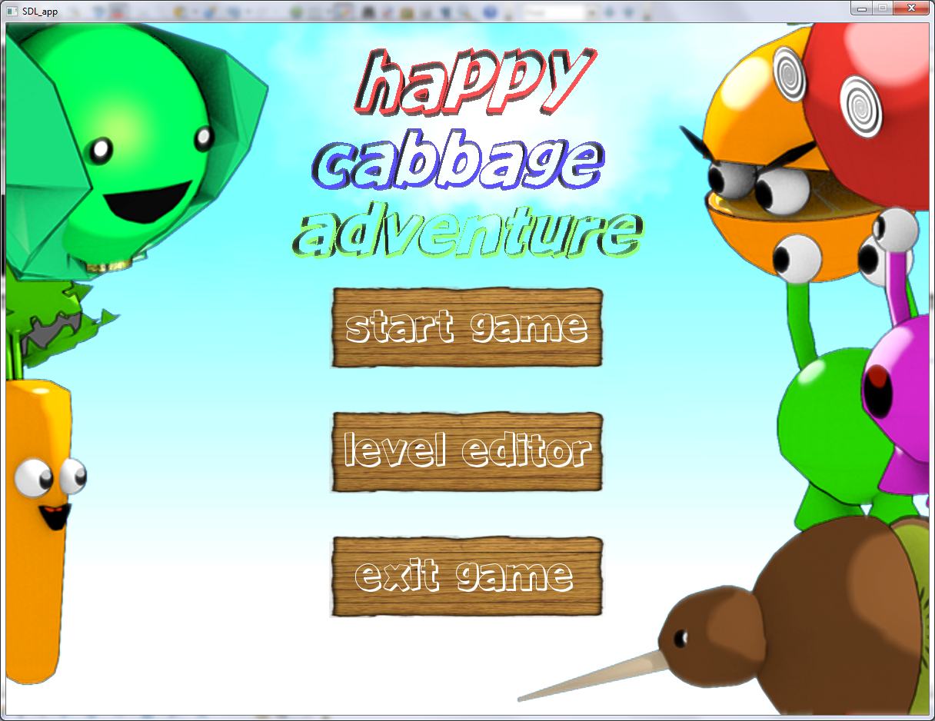

Start Game
Takes you to the Overworld Map
Level Editor

Opens up the Level Editor (see page INSERT)
Exit Game

Closes the game
Viewing the Overworld Screen
Gameplay
This map shows the world of Pleasant Produce Land. The game begins in the Peaceful Plains, where your friendly pal Carrot will show you the ropes of this new world. To continue working your way through the world and rescuing your veggie friends, you need to clear the levels. Upon completion, a flag will appear over the level, and the adjacent level will open. To move from level to level, use the A and D keys (or the arrow keys). To enter a level, move Happy Cabbage over the level and press the Spacebar.
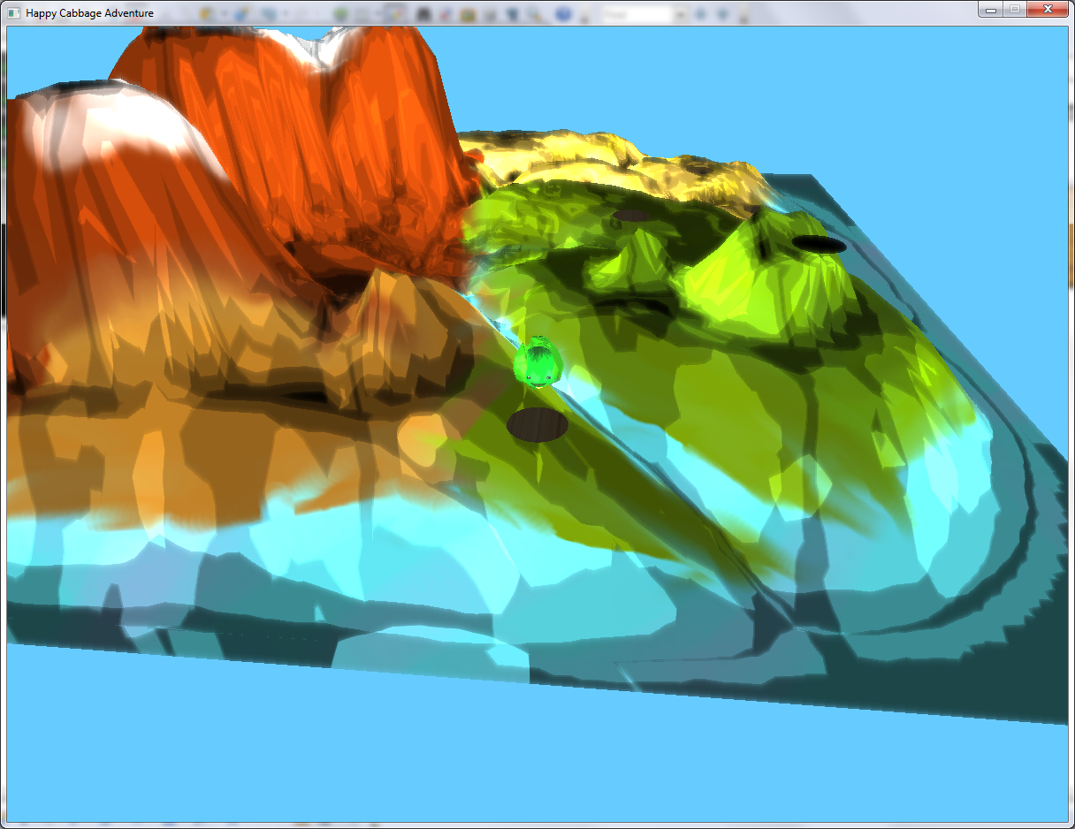

Viewing the Game Screen
Once you enter a level, a screen similar to the following will appear:
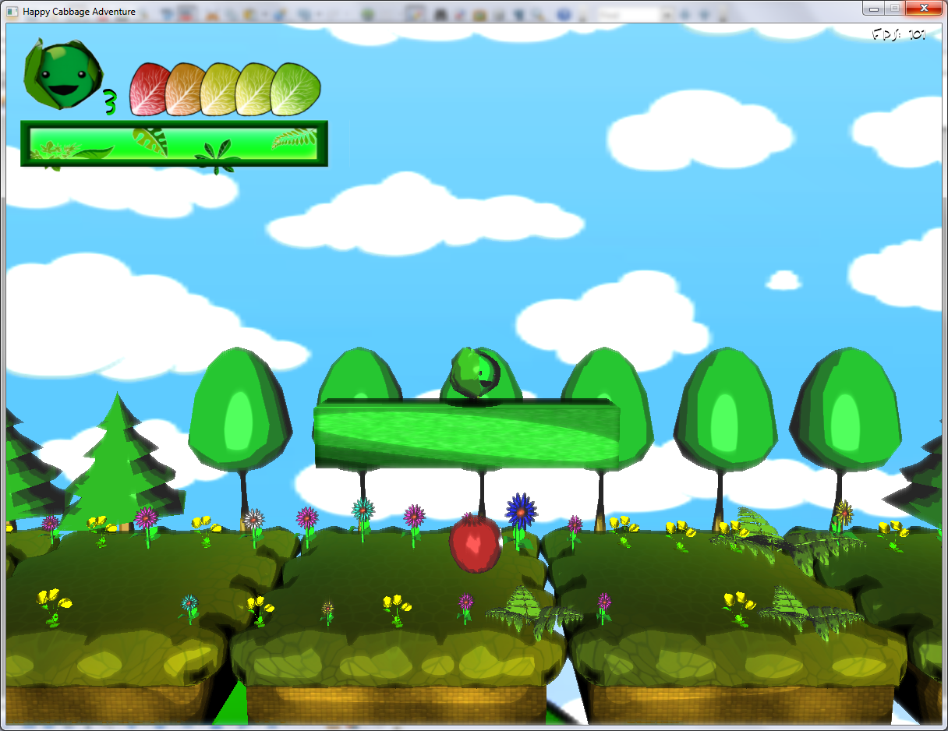
To complete the level, you must jump, blast, and dash your way successfully to the flag. Once you pass the flag, the level is marked as cleared, and further levels will open up on the Overworld map. Once a level has been cleared, you may replay it as many times as you like.

Viewing the HUD
Once in a level, Happy Cabbage's status is shown in the upper-left hand corner of the screen. The below diagram shows what the various elements of the HUD (Heads-Up Display) mean.
Life Count
Health
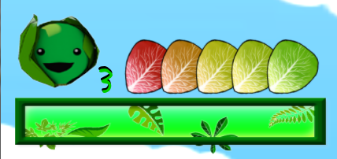
Energy Bar
Cabbage Status
Life Count: The number of lives Happy Cabbage has remaining. If this number reaches 0, it's Game Over!
Health: Happy Cabbage's leaf count. If Happy Cabbage runs out of leaves, he will wilt and lose a life. Happy Cabbage starts with a maximum of 5 leaves. Rumor has it that Happy Cabbage's total leaf count can be increased somehow.
Cabbage Status: This shows Happy Cabbage's mood. If Happy Cabbage is damaged, powered up, or otherwise changed, this icon will show it.
Energy Bar: The amount of Energy Happy Cabbage has. This Energy can be used to perform a variety of special abilities, such as the Leaf Shield and Solar Beam. Happy Cabbage initially starts with a maximum of 3 charges. Some say that Happy Cabbage can gain more maximum charges if he finds certain items...

Damage and Death
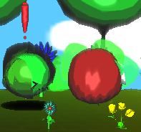
As Happy Cabbage progresses through Pleasant Produce Land, he will face a variety of challenges, fruits, and aliens that will attempt to keep him from his friends. When Happy Cabbage is damaged, he will lose one or more leaves. Happy Cabbage can lose leaves in one of 2 ways:
- Be struck by an enemy or an enemy's projectile
- Touch a trap (such as fire or blades)

Happy Cabbage loses a life when he runs out of health,
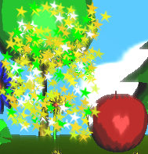
or if one of the following happens:
- Happy Cabbage falls below the stage line
- Happy Cabbage is sandwiched between walls

When Happy Cabbage loses all his lives,
the game over screen will be displayed,
and the game will return to the Overworld screen. GAME OVER HERE
Happy Cabbage may then choose to either
retry the level, or return to a prior level.

Items
Throughout Pleasant Produce Land there are a variety of items that will help Happy Cabbage along his way. Some of these items are listed below:

Leaf:
This helpful little item can be found throughout Pleasant Produce Land. It heals Happy Cabbage for one leaf of damage.
Water Droplet:
This helpful little item can be found throughout Pleasant Produce Land. It restores one
Energy.

There are several other items hidden throughout Pleasant Produce Land with mystical properties... keep an eye out for them!

Happy Cabbage's Abilities
As Happy Cabbage travels through Pleasant Produce Land, he will learn a variety of abilities to help him complete his quest. A few of these abilities are noted below:


Solar Beam: This devastating
attack requires a long charge time,
but when released, decimates all in its path. This move uses one Energy. Happy Cabbage starts off with this powerful ability.

Leaf Shield: Happy Cabbage protects himself
in a flurry of leaves with this ability. While the
leaf shield is activated, Happy Cabbage is immune to damage, and every enemy he touches is (pushed back?) destroyed. This move uses one Energy. Happy Cabbage starts off with this ability.

Level Editor
Team Lead
Credits
Alden Tai

Programmers
Alden Tai
Chris Colwell
Damien Espinola
Ian Dunn
Jorge Mendoza

Character Designer
Ryan IneedToLearnYourLastNamePerson

Special Thanks
Dr. Zoe(umlaut this!) Wood
All Our Faithful Beta Testers
You

